



**A**

**Project Report**

on

**Experimental Analysis of Disease prediction Using Machine Learning**

submitted as partial fulfillment for the award of

**BACHELOR OF TECHNOLOGY**

**DEGREE**

SESSION 2023-24

in

**Computer science**

By

Gaurav Dubey (2000290120065)

Hardik Soni (2000290120068)

Pushkar Saraswat (2100290129006)

**Under the supervision of**

Prof. Shivani

**KIET Group of Institutions, Ghaziabad**

Affiliated to

**Dr. A.P.J. Abdul Kalam Technical University, Lucknow**

(Formerly UPTU)

**May, 2024**

**DECLARATION**

I/We hereby declare that this submission is our own work and that, to the best of our knowledge and belief, it contains no material previously published or written by another person nor material which to a substantial extent has been accepted for the award of any other degree or diploma of the university or other institute of higher learning, except where due acknowledgment has been made in the text.

Date: -11/03/2024

Signature: - Signature: -

Name: - Gaurav Dubey Name: -Hardik Soni

Roll No.: - 2000290120065 Roll No.: - 2000290120068

Signature:-

Name:- Pushkar Saraswat

Roll No.:- 2100290129006



**DEPARTMENT OF COMPUTER SCIENCE**

**CERTIFICATE**

This is to certify that Project Report entitled “**NUTI**” which is submitted by **Gaurav Dubey, Hardik Soni And Pushkar Saraswat** in partial fulfilment of the requirement for the award of degree B. Tech. in Department of Computer Science of Dr A.P.J. Abdul Kalam Technical University, Lucknow is a record of the candidates own work carried out by them under my supervision. The matter embodied in this report is original and has not been submitted for the award of any other degree.

**Signature of Supervisor**

**Supervisor Name:** Prof. Shivani

**Date:**

**ACKNOWLEDGEMENT**

It gives us a great sense of pleasure to present the report of the B. Tech Project undertaken during B. Tech. Final Year. We owe special debt of gratitude to Professor Shivani, Department of Computer Science, KIET, Ghaziabad, for his/her constant support and guidance throughout the course of our work. Her sincerity, thoroughness and perseverance have been a constant source of inspiration for us. It is only his cognizant efforts that our endeavors have seen light of the day.

We also take the opportunity to acknowledge the contribution of Dr. Ajay Kumar Shrivastava, Head of the Department of Computer Science, KIET, Ghaziabad, for his full support and assistance during the development of the project. We also do not like to miss the opportunity to acknowledge the contribution of all the faculty members of the department for their kind assistance and cooperation during the development of our project.

Last but not least, we acknowledge our friends for their contribution in the completion of the project.

Date :

Signature: Signature:

Name : Gaurav Dubey Name: Hardik Soni

Roll No.: 2000290120065 Roll No.: 200290120068

Signature:

Name : Pushkar Saraswat

Roll No.: 2100290129006

**ABSTRACT**

An e-commerce website that permits a customer to purchase items and/or services from a store that are not only globally available but also connects the local stores. This website will be a one stop solution for the customers as it will be able to compare the prices of the item searched by the customers in an efficient manner with global as well as local distributors. It also provides a choice to the customer to either search the item through company name, product name. Additionally, helps the retailers and shopkeepers to expand their network by connecting to the local customers with the help of technology. Lastly, will satisfy the customer with the product availability at least price and by conducting successful user review. This project named Naturally Unique treasures & items (NUTI) aims to leverage modern technologies like Django using python to create a comprehensive e-commerce web application.

|  |  |
| --- | --- |
| **TABLE OF CONTENTS** | **Page**  **No.** |
| DECLARATION……………………………………………………………………. | ii |
| CERTIFICATE……………………………………………………………………… | iii |
| ACKNOWLEDGEMENTS…………………………………………………………. | iv |
| ABSTRACT………………………………………………………………………..... | v |
| LIST OF FIGURES………………………………………………………………….. | viii |
| LIST OF TABLES…………………………………………………………………  LIST OF ABBREVIATIONS……………………………………........................... | x  xi |
|  |  |

CHAPTER 1 (INTRODUCTION ) Page No.

1.1 Introduction to Project 1

1.2 Project Category (Internet Based, Application Or 2

System Development, Research Based, Industry Automation,

Network Or System Administration/ Machine Learning Based)

1.3 Objectives 2

1.4 Problem Formulation 3

1.5 Proposed System 4

CHAPTER 2.( REQUIREMENT ANALYSIS AND SYSTEM SPECIFICATION)

2.1 Feasibility Study (Technical, Economical, Operational) 5

2.2 Software Requirement Specification Document Which Must Include the 5

Following: (Data Requirement, Functional Requirement, Performance

Requirement, Maintainability Requirement, Security Requirement)

2.3 SDLC Model to Be Used 12

CHAPTER 3. (SYSTEM DESIGN)

3.1 Detail Design 14

3.2 System Design Using Dfd Level 0 And Level 1 15

3.3 Use Case Diagram 16

3.4 Database Design 17

3.4.1 ER Diagrams 18

CHAPTER 4. (IMPLEMENTATION, TESTING, AND MAINTENANCE)

4.1 Introduction To Languages, Tools And Technologies Used For Implementation 19

4.2 Testing Techniques And Test Cases Used 20

CHAPTER 5. (RESULTS AND DISCUSSIONS)

5.1 User Interface Representation (Of Respective Project) 22

5.2 Snapshots Of System With Brief Detail Of Each 24

5.3 Back End Representation (Database To Be Used 31

5.3.1 Snapshots Of Database Tables With Brief Description 31

CHAPTER 6. (CONCLUSION AND FUTURE SCOPE ) 32

REFERENCES (Only in IEEE Style) 34

Research Paper 38

Acceptance of Research Paper 38

Patent 50

**LIST OF FIGURES**

**Figure No. Description Page No.**

Figure 3.1 Flowchart

Figure 5.1 Register page

Figure 5.2 Product Login page

Figure 5.3 Home page

Figure 5.4 Product page

Figure 5.5 Product description page

**LIST OF TABLES**

**Table. No. Description Page. No.**

**LIST OF ABBREVIATIONS**

**CHAPTER 1**

**INTRODUCTION**

* 1. **INTRODUCTION**

Businesses around the world are currently faced with a choice: adapt to the ever-changing landscape of technology, or risk becoming obsolete by clinging to traditional brick-and-mortar practices [1]. Enterprises are struggling to stay relevant in the face of fierce competition from online retail giants such as Amazon. We hope to provide a solution to various retailers and shop owners through this project by making it easier for them to attract local customers who want to buy their desired products at the most competitive prices and from nearby locations. When it comes to item selection, our project revolves around catering to customer preferences. The primary goal of our initiative is to develop a website that efficiently meets customer demands while minimizing costs.

* 1. **PROJECT CATEGORY**

The technical project category of a “ **A Comprehensive Study On Local Retail Through Innovative Strategies**” includes various components such as Front-end development, back-end development and databases .

* 1. **OBJECTIVES**

This website will be one stop solution for the customers as it will :

* Compare the prices of the item searched by the customers in an efficient manner
* Provide a choice to the customer to either search the item through company name, product name.
* Help the retailers and shopkeepers to expand their network by connecting to the local customers with the help of technology
* Satisfy the customer with the product availability in least price and by conducting successful user review.

**1.4 PROBLEM FORMULATION**

.

**1.5 PROPOSED SYSTEM**

**CHAPTER 2**

**REQUIREMENT ANALYSIS AND SYSTEM SPECIFICATION**

1. **FEASIBILITY STUDY**

* **Technical Feasibility:**

Evaluate the availability of technology and infrastructure required to develop and maintain the platform.

Assess the compatibility of the chosen technology stack with the desired features and scalability requirements.

Determine if the technical resources, skills, and expertise needed to build and support the platform are readily available.

* **Operational Feasibility:**

Assess the platform's operational requirements, including staffing, management, and maintenance.

Evaluate the feasibility of managing user interactions, content moderation, and community support.

Consider the scalability and responsiveness of the platform to handle increasing user demands and ensure smooth operations.

* **Economic Feasibility:**

Conduct a cost-benefit analysis to determine the economic viability of the platform.

Evaluate the estimated development costs, including infrastructure, software, and human resources.

**2.2 SOFTWARE REQUIREMENT SPECIFICATION DOCUMENT**

* **Data Requirements:**

User Profiles:

The system needs to store comprehensive user profiles containing relevant information about each user. This includes usernames, passwords (stored securely using encryption techniques), contact details such as phone numbers and email addresses.

Database Data:

Database data refers to the structured information stored within a database management system (DBMS) that is organized and accessible for efficient retrieval and manipulation. It encompasses various types of data, such as text, numbers, dates, and multimedia files, all stored in a structured manner within tables, rows, and columns. Database data plays a vital role in modern businesses and organizations, serving as a foundation for decision-making, analysis, and day-to-day operations.

Activity Logs:

To keep track of user interactions and maintain a record of changes made to the system's content, activity logs are necessary. These logs capture the actions performed by users, such as editing or updating saved data, and also record project contributions made by users. By maintaining activity logs, it becomes easier to track changes, review user contributions, and provide a history of interactions within the system.

* **Functional Requirements:**

User Registration and Authentication:

The application should allow users to create accounts by providing necessary details such as username, password, and email.

Users should be able to authenticate themselves securely using their credentials to access their accounts.

User Profile Management:

Users should have the ability to create and manage their profiles.

The application should allow users to input and update their personal information, such as contact details, professional title or objective, location, and a summary highlighting their qualifications and career goals.Users should be able to add their medical background history. The application can provide templates or guidance to help users create effective profiles.

Security and Data Privacy:

The application should implement appropriate security measures to protect user data, including encryption of sensitive information and secure storage of user credentials.

The application should comply with relevant data protection regulations to ensure user privacy and consent.

* **Performance Requirements:**

Responsiveness:

The application should respond quickly to user interactions, such as navigating between sections, editing content, or saving changes.

The response time for each action should be within milliseconds to provide a smooth and seamless user experience.

Loading Time:

The application should load quickly, particularly when users access their resumes or templates.

The initial loading time should be minimal to ensure that users can start working on their resumes without significant delays.

Scalability:

The application should be able to handle a growing number of users and resumes without significant degradation in performance.

As the user base expands, the application should scale horizontally by adding additional resources or utilizing cloud-based infrastructure.

Concurrent Users:

The application should be capable of supporting multiple concurrent users without experiencing performance issues or slowdowns.

It should handle simultaneous requests from different users effectively and maintain responsiveness throughout.

File Size and Storage:

Resumes and related files should be stored efficiently to minimize storage requirements and optimize performance.

The application should handle files of various sizes, from small resumes to larger attachments, without impacting performance during file uploads or downloads.

Caching and Optimization:

Implement caching mechanisms to store frequently accessed data, such as templates or user preferences, to reduce database queries and improve response times.

Optimize database queries, API calls, and resource utilization to ensure efficient use of system resources and reduce response times.

Integration Performance:

If the application integrates with external systems, such as job portals or cloud storage services, ensure that data retrieval and synchronization processes are efficient.

Minimize delays and errors during data transfers to provide a seamless user experience and maintain data consistency.

Error Handling:

The application should handle errors gracefully, providing meaningful error messages and recovering from failures without compromising overall performance.

Error handling mechanisms should be in place to identify and resolve issues quickly to minimize downtime and maintain the application's performance.

Performance Monitoring:

Implement performance monitoring tools to track system performance, identify bottlenecks, and proactively address any performance-related issues.

Continuously monitor response times, server load, database performance, and other relevant metrics to ensure optimal application performance.

* **Maintainability Requirements:**

Modularity and Component-based Architecture:

The application should be designed with a modular architecture that allows for independent development and maintenance of different components.

Use component-based design patterns to ensure that individual modules can be updated or replaced without impacting the overall functionality of the application.

Code Readability and Documentation:

Ensure that the application code follows consistent coding conventions and is well-documented to enhance readability and ease of maintenance.

Document the purpose, functionality, and dependencies of each module or component to assist developers in understanding and maintaining the code base.

Separation of Concerns:

Apply the principle of separation of concerns to ensure that different parts of the application have well-defined responsibilities and are decoupled from each other.

This promotes code maintainability by making it easier to isolate and fix issues or add new features without affecting unrelated parts of the application.

Version Control and Source Code Management:

Utilize a version control system, such as Git, to manage the source code repository effectively.

Enforce best practices for branching, merging, and commit messages to ensure traceability and facilitate collaboration among developers.

Maintain a clear release management process to manage different versions of the application and track changes over time.

Automated Testing and Test Coverage:

Implement a comprehensive suite of automated tests to validate the functionality of the application and ensure that changes or updates do not introduce regressions.

Aim for high test coverage to minimize the risk of undiscovered bugs and facilitate efficient maintenance by quickly identifying affected areas when modifications are made.

Error Logging and Monitoring:

Implement robust error logging mechanisms to capture and record errors that occur during application usage.

Monitor and analyze error logs to identify recurring issues or patterns and proactively address them to improve the stability and maintainability of the application.

Dependency Management:

Manage external dependencies effectively by using package managers and dependency resolution tools.

Regularly update dependencies to leverage bug fixes, security patches, and new features provided by the dependency providers.

Documentation and Knowledge Base:

Maintain comprehensive documentation that describes the architecture, design decisions, deployment procedures, and configuration details of the application.

Establish a knowledge base or wiki to document common issues, troubleshooting steps, and solutions to facilitate efficient maintenance and support.

Continuous Integration and Deployment:

Implement a CI/CD (Continuous Integration/Continuous Deployment) pipeline to automate the build, test, and deployment processes.

This helps ensure that changes are thoroughly tested before being deployed, reducing the risk of introducing issues into the production environment.

Regular Code Reviews and Refactoring:

Conduct regular code reviews to identify areas for improvement, code smells, and potential performance bottlenecks.

Encourage refactoring of code to enhance maintainability, readability, and adherence to best practices.

* **Security Requirements:**

User Authentication and Authorization:

Implement a secure user authentication mechanism, such as password-based authentication or multi-factor authentication, to ensure that only authorized users can access the application.

Enforce strong password policies, including requirements for complexity and regular password updates, to protect user accounts from unauthorized access.

Secure Data Storage:

Store sensitive user information, such as usernames, passwords, and contact details, in a secure manner.

Utilize encryption techniques, such as hashing and salting, to protect stored passwords from unauthorized disclosure.

Employ secure database configurations and access controls to prevent unauthorized access to user data.

Secure Communication:

Encrypt all communication between the client and the server using secure protocols, such as HTTPS, to prevent eavesdropping and data tampering.

Implement secure coding practices to prevent common web application vulnerabilities, such as cross-site scripting (XSS) and SQL injection attacks.

Role-Based Access Control:

Implement role-based access control (RBAC) to ensure that users have appropriate access privileges based on their roles and responsibilities.

Restrict access to sensitive functionality or data based on user roles to prevent unauthorized actions or data exposure.

Data Privacy and Protection:

Comply with data protection regulations, such as GDPR (General Data Protection Regulation) or CCPA (California Consumer Privacy Act), to ensure the privacy and protection of user data.

Obtain user consent when collecting personal information and provide clear and transparent information on how user data is processed, stored, and shared.

Secure File Handling:

Implement secure file upload and download mechanisms to prevent the uploading or downloading of malicious files.

Validate file types, sizes, and content to ensure that only safe and authorized files are processed by the application.

Regular Security Updates:

Stay updated with the latest security patches and updates for all software components, frameworks, libraries, and dependencies used in the application.

Monitor security advisories and promptly apply patches to address identified vulnerabilities and ensure a secure environment.

Session Management:

Implement secure session management techniques, such as session timeouts and secure session storage, to mitigate the risk of session hijacking or session fixation attacks.

Enforce proper session invalidation and logout mechanisms to ensure that user sessions are terminated securely.

Secure Third-Party Integrations:

Evaluate the security practices and reputation of third-party services or APIs used in the application.

Implement secure integration patterns and protocols when interacting with external services to protect against data breaches or unauthorized access.

Security Testing and Auditing:

Conduct regular security testing, including vulnerability scanning, penetration testing, and code reviews, to identify and address security vulnerabilities.

Perform security audits to assess the overall security posture of the application and validate compliance with security standards and best practices.

1. **SDLC MODEL TO USE**

* Iterative Model:

The iterative model is a software development methodology that focuses on breaking down the software development lifecycle into smaller, incremental iterations. It is a popular approach used by development teams to build complex software systems while emphasizing flexibility, adaptability, and continuous improvement.

In the iterative model, the development process consists of a series of iterations, with each iteration representing a mini-project. Each iteration follows a cyclical pattern, typically including requirements gathering, analysis, design, implementation, testing, and evaluation. The key principle of this model is to develop software incrementally, with each iteration building upon the work completed in previous iterations.

One of the primary advantages of the iterative model is its ability to accommodate changing requirements and adapt to evolving project needs. Unlike traditional waterfall models, where requirements are typically fixed at the beginning of the project, the iterative model allows for the incorporation of new requirements or modifications as the project progresses. This flexibility enables development teams to respond to customer feedback, changing market conditions, and emerging technological advancements.

The iterative model promotes collaboration and continuous feedback throughout the development process. Stakeholders, including clients, end-users, and development teams, are actively involved in each iteration. This involvement fosters effective communication, requirements clarification, and alignment of expectations. It allows for the early identification of issues, risks, or misunderstandings, enabling timely adjustments and mitigations.

Each iteration in the iterative model results in a functional and potentially deployable software increment. This incremental delivery of working software provides several benefits. First, it allows stakeholders to have early access to tangible results and make informed decisions based on the actual software functionality. Second, it facilitates early user feedback, which can be invaluable in identifying improvements or modifications necessary to meet user needs and expectations.

Another advantage of the iterative model is the ability to prioritize requirements and allocate resources effectively. By working in iterations, development teams can focus on the most critical and high-value requirements first, delivering incremental value to stakeholders early in the project. This iterative prioritization helps manage project scope and ensures that the most crucial features are implemented and tested before less critical ones.

The iterative model also enables faster time-to-market. As functional increments are delivered at the end of each iteration, it is possible to release a working product or a minimum viable product (MVP) to the market earlier than in traditional development models. This allows organizations to gain a competitive edge, gather user feedback, and generate value while subsequent iterations continue to enhance the software.

**CHAPTER 3**

**SYSTEM DESIGN**

1. **DETAIL DESIGN**
   * + User Interface Design:

The application should have an intuitive and user-friendly interface, with clear navigation and well-organized sections.

The design should be responsive, ensuring compatibility with various devices and screen sizes.

The user interface should provide visually appealing resume templates, customizable formatting options, and real-time previews to enhance the user experience.

* + - Database Design:

The application should utilize a robust database management system to store and manage user data, including user profiles, resumes, and activity logs.

User profiles can be stored in a dedicated table, with fields such as username, password (encrypted), contact details, and other profile information.

Activity logs can be stored in a separate table, recording user interactions, changes made to resumes, and project contributions, with appropriate timestamps.

* + - Authentication and Security:

User authentication should be implemented using secure mechanisms, such as password hashing and salting.

The application should enforce password complexity rules and provide secure password recovery options.

Role-based access control can be implemented to manage user permissions and restrict access to sensitive features or data.

* + - Profile Management:

Users should have the ability to create, update, and delete their profiles.

Profile information can be stored and retrieved from the user profiles table in the database.

Validation checks should be implemented to ensure data integrity and accuracy.The application should provide tools for arranging sections, adding new sections, and reordering existing sections within the resume.

1. **SYSTEM DESIGN USING DFD LEVEL - 0, LEVEL – 1**

* **DFD Level - 0:**

At the level 0 DFD, you would have a single process symbol representing the entire system, which is the resume builder application for user. This process symbol would be connected to external entities, representing the external users or systems interacting with the platform.

Figure 3.1. Zero Level DFD

* **DFD Level 1:**

The level 1 DFD provides a more detailed view of the system by decomposing the main process into smaller sub processes.

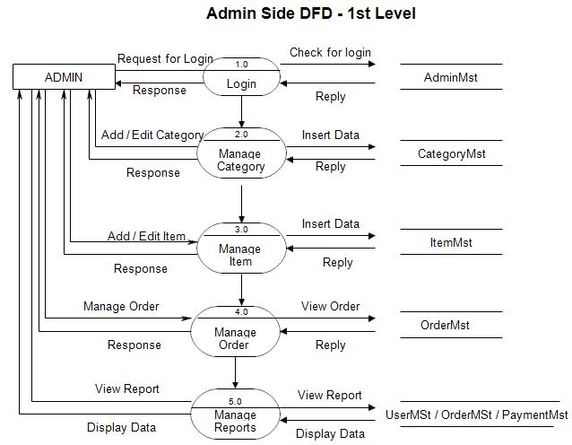

Figure 3.2. Level 1 DFD

1. **USE CASE DIAGRAM**

A use case diagram for a social media platform for developers represents the various interactions between actors (users) and the system. It provides an overview of the system's functionalities and the actors involved. The diagram focuses on the actions or use cases that users can perform within the platform.

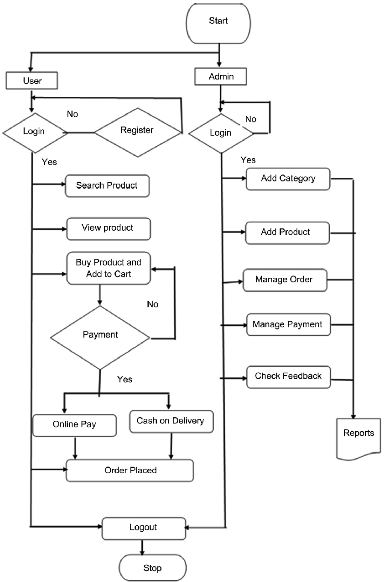

Figure 3.3. Use Case Diagram

1. **DATABASE DESIGN**

The database design for a resume-building application includes several essential tables. The User table stores user-related information like user ID, username, password, email, and other relevant details. The table contains resume-specific data, such as the doctor ID, associated user ID, title, summary, format, design preferences, and privacy settings. The table manages doctor ID (as a foreign key), name, degree, major, and start and end dates. The Work Experience table stores information about the user's patient history, including experience ID, patient ID (as a foreign key), patient name, job title, start and end dates, and job description. The disease table keeps track of the user's symptoms, with fields such as patient ID, PID (as a foreign key), symptoms. By organizing data into these tables and establishing relationships between them, the health application can efficiently store and retrieve information to assist users in creating and managing their reports.

**3.4.1 ENTITY RELATIONSHIP DIAGRAM**

An entity relationship diagram (ERD) shows the relationships of entity sets stored in a database. An entity in this context is a component of data. In other words,ER diagrams illustrate the logical structure of databases.

Figure 3.4. Entity Relationship Diagra

**CHAPTER 4**

**IMPLEMENTATION, TESTING, AND MAINTENANCE**

1. **Introduction to Languages, Tools And Technologies**

Developing a social media platform for developers requires the use of various languages, tools, and technologies to ensure efficient and robust implementation. Here's an introduction to some of the commonly used technologies in this context:

Programming Languages:

* Backend Development: Languages like Python, Java, PHP, or Node.js are often used for server-side development, handling data processing, and implementing the core functionalities of the platform.
* Frontend Development: HTML, CSS, and JavaScript are essential for building the user interface (UI) and enabling interactive features on the client-side.
* Web Frameworks:

Backend Frameworks: Frameworks like Express.js (Node.js), firebase, firestore provide a structured approach to backend development, offering libraries and tools to handle routing, database integration, authentication, and more.

Frontend Frameworks: Popular choices include React, Angular, or Vue.js, which offer efficient UI component management, state management, and data binding for building dynamic and responsive user interfaces.

Database Management Systems (DBMS):

* Relational Databases:

MySQL, are commonly used for structured data storage, providing features like querying, indexing, and ensuring data integrity.

* Version Control:

Git, a widely used version control system, allows developers to track and manage code changes, collaborate effectively, and maintain a history of the project's development.

Machine Learning:

* Machine Learning (ML) is a branch of artificial intelligence (AI) that focuses on developing algorithms and models capable of learning and making predictions or decisions without being explicitly programmed. ML algorithms are designed to analyze and interpret patterns and relationships within datasets to generate insights and predictions. By leveraging large amounts of data and powerful computational capabilities, ML algorithms can detect complex patterns, trends, and correlations that might otherwise go unnoticed. ML has a wide range of applications across various industries, including healthcare, finance, marketing, and robotics.

1. **TESTING TECHNIQUES AND TESTCASES USED**

Testing techniques and test cases play a crucial role in ensuring the quality and reliability of a resume building platform for developers. Here are some common testing techniques and test cases used in this context:

* **Functional Testing:**

Test user registration by providing valid and unique usernames, passwords, and email addresses. Verify that new user accounts are created successfully.

Test user authentication by entering valid credentials and verifying that the user is able to log in successfully.

Test invalid credentials and ensure that the system rejects unauthorized login attempts.

User Profile Management:

Test profile creation by inputting valid information and verifying that a new profile is created for the user.

Test profile updating by modifying profile fields and confirming that the changes are reflected in the database.

Test profile retrieval by requesting profile information for a specific user and ensuring that the correct data is returned.

Test profile deletion and verify that the profile is successfully removed from the system.

* **Usability Testing:**

User Interface (UI) Testing: Validate the design and layout of the user interface, ensuring it is intuitive, visually appealing, and user-friendly.

Navigation Testing: Test the navigation flow within the platform, ensuring that users can easily access different features, pages, and sections.

Error Handling: Verify that appropriate error messages are displayed when users encounter errors or perform invalid actions, and check that error handling is consistent throughout the platform.

* **Performance Testing:**

Load Testing: Simulate a large number of users concurrently accessing the platform to assess its performance under high load and identify potential bottlenecks or performance issues.

Response Time Testing: Measure the response time of various functionalities (e.g., posting content, loading profiles) to ensure they meet acceptable performance standards

Scalability Testing: Test the platform's ability to handle an increasing number of users, posts, and interactions without significant degradation in performance.

* **Security Testing:**

Authentication and Authorization: Verify that user authentication mechanisms, such as login and session management, are secure and prevent unauthorized access to user accounts.

Data Privacy: Test that user data, including personal information and messages, is properly protected, encrypted, and inaccessible to unauthorized users.

Vulnerability Testing: Conduct security scans and penetration testing to identify and fix any potential vulnerabilities or loopholes in the platform's code, APIs, or server configurations

* **Integration Testing:**

API Integration: Test the integration of external APIs (e.g., social media APIs, authentication services) to ensure proper functionality and data exchange between the platform and third-party systems.

Database Integration: Validate the interaction between the platform and the database, ensuring proper data storage, retrieval, and synchronization.

**CHAPTER 5**

**RESULTS AND DISCUSSIONS**

The modern business world moves at breakneck speed, making it critical for businesses to have a strong online presence and e-commerce platform. With this project, we are taking a significant step toward fully utilizing Django to create a dynamic and comprehensive e-commerce website. The ultimate goal of our project is to meet the evolving needs of the e-Business industry while demonstrating the practical application of these cutting-edge technologies [5]. This e-commerce website is specifically designed to meet the changing demands of the clients in the local area to a business. It functions as a central hub for buying and selling items commonly used in day-to-day life, creating a sense of camaraderie and facilitating connections among sellers and buyers. More than just a platform for purchases, it is a dynamic space for both online shopping and offline shopping. This project is focused on solving the key dilemma faced by sellers: the absence of a comprehensive and easily accessible platform for delivering their products to the local citizens and making them known globally. It connects them with peers who are interested in buying and knowing the prices of the goods sold by them. By tackling this challenge head-on, the ecommerce web application strives to enhance the everyday experiences of customers, cultivating a thriving environment of bespoke services and products tailored specifically to the needs and desires of the youth in India.

1. **User Interface Representation (Of Respective Project)**

The following figure shows the landing page of our website

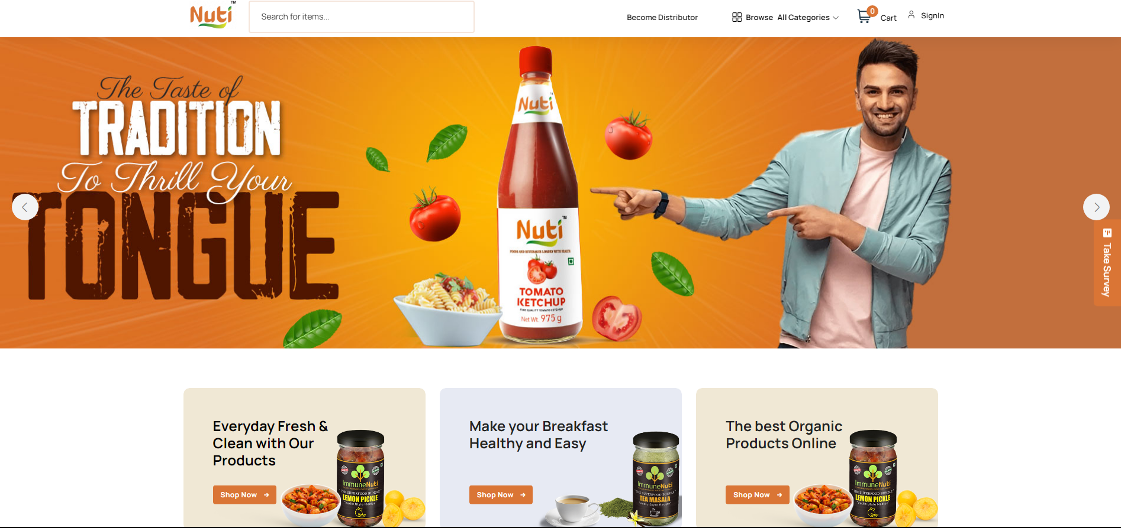

Figure 5.1. Successfully launching the website

The following image shows that user is able to create their account

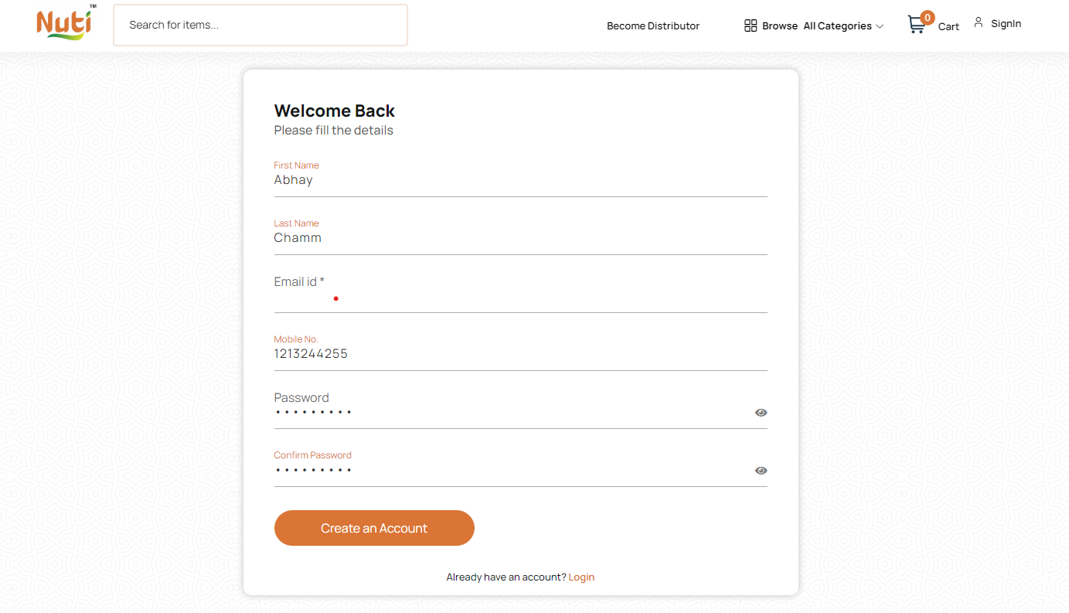

Figure 5.2 Accuracy of creating account

1. **Snapshots of Add to cart**

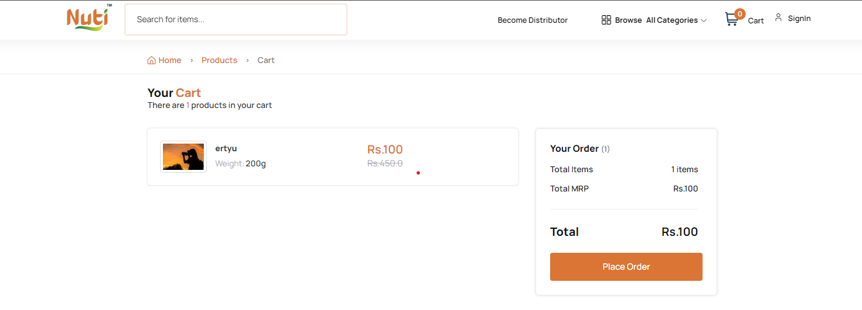

Figure 5.3 Accuracy of adding the product in cart

**Payment Gateway:**

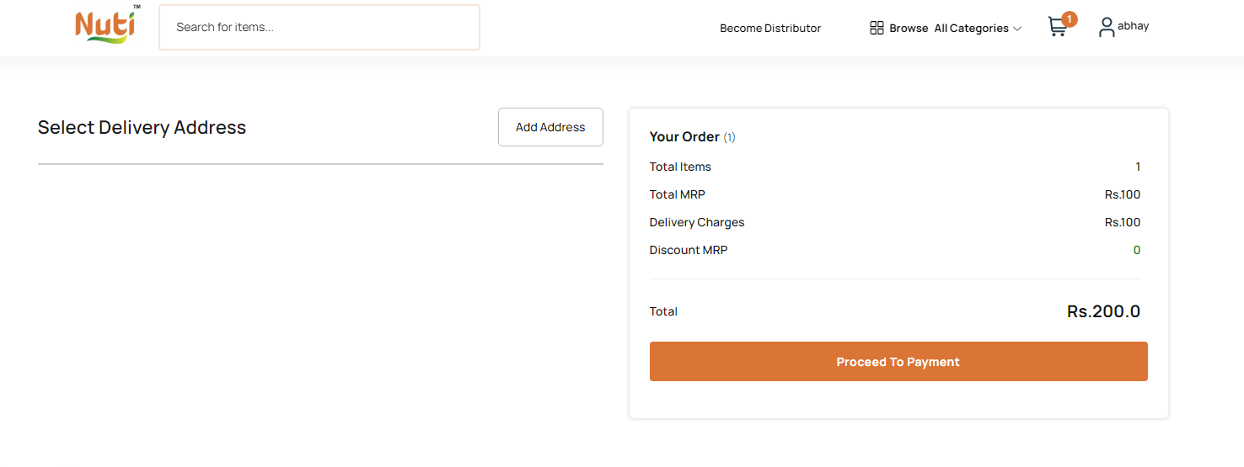

Figure 5.5 User is able to do payment

* **Accuracy table as per the website:**

|  |  |  |  |
| --- | --- | --- | --- |
| Feature | Description | Benefit for Customers | Benefit for Retailers |
| Price Comparison Tool | Users search for a product and see a comparison table displaying prices from various local retailers. | Find the best deals and lowest prices. | Attract customers searching for specific products. |
| Search Functionality | Option to search by product name or company name. | Easily find desired products regardless of brand familiarity. | Increase discoverability for a wider range of products. |
| Retailer Network Expansion | Local retailers can register and connect with local customers. | Reach a wider customer base and expand their online presence. | Gain access to a platform for promoting products and services. |
| Product Availability Indicator | Shows if a product is in stock at a particular retailer. | Avoid wasted trips to stores without desired items. | Improve customer satisfaction and potentially increase sales. |
| User Review System | Customers can leave reviews on products and retailers. | Make informed purchase decisions based on real user experiences. | Gain valuable customer feedback and potentially improve brand reputation. |

Figure 5.7 table of accuracy of website

* 1. **BACKEND RESPRESENTATION (Python)**

The back-end representation of a social media platform for developers involves the implementation of various components and technologies that handle the server-side operations and data management.

* + 1. **SNAPSHOT OF CODE**

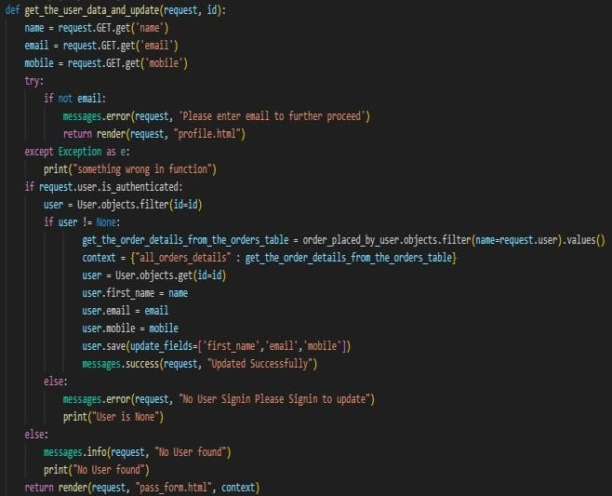

**Order code**

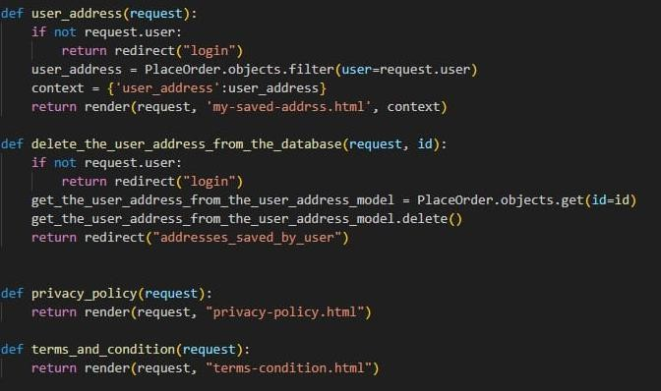

**Redirections code**



**User Data Update Code**

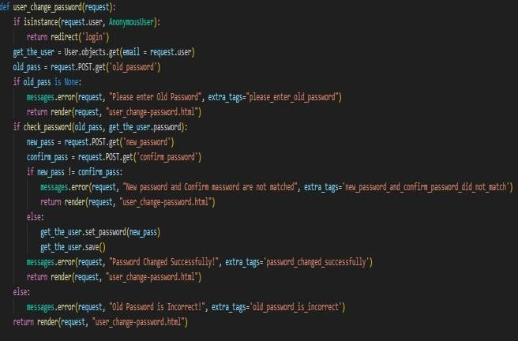

**Code of login page**

**CHAPTER 6**

**CONCLUSION AND FUTURE SCOPE**

Conclusion:

In conclusion, this project has developed a comprehensive website designed to be a one-stop shop for price comparison and local product discovery. By empowering customers with features like price comparisons, flexible search options, and user reviews, the website aims to streamline the shopping experience and ensure customers find the best deals on the products they need.

Furthermore, the platform fosters connections between local retailers and customers, expanding the retailers' reach and fostering a thriving online marketplace within the community. This project has the potential to significantly improve customer satisfaction, promote local businesses, and ultimately boost the local economy.

This is just the beginning, and future iterations could explore integrating additional features such as product recommendations, personalized deals, and loyalty programs. By continuously innovating and adapting to user needs, this website has the potential to become an essential resource for both customers and retailers in the local community.

Future Scope:

Advanced Features:

Price tracking and alerts: Implement a system that tracks price fluctuations and allows users to set alerts for specific products. This can notify them when a desired item reaches their target price.

Personalized recommendations: Leverage user search history and purchase data to suggest relevant products and deals tailored to individual customer preferences.

Image recognition integration: Allow users to search for products by uploading an image. This could be particularly helpful for finding specific clothing items or identifying unknown products seen elsewhere.

Universal product code (UPC) scanner: Integrate a barcode scanner that allows users to scan product codes in physical stores and instantly compare prices across online retailers.

Expanding Functionality:

Market expansion: Consider extending your platform to include a wider geographical area, allowing users to compare prices from retailers in different regions.

Integrate with online marketplaces: Partner with major online marketplaces to display product offerings directly on your platform. This would provide a more comprehensive price comparison experience.

Multilingual support: Cater to a broader audience by offering your website in multiple languages. This can attract users from diverse backgrounds and increase your website's reach.

B2B functionality: Explore offering a separate platform or features specifically designed for businesses to compare prices on bulk purchases or wholesale items.

Additional Considerations:

Focus on user experience: Continuously gather user feedback and conduct A/B testing to optimize the website's design, layout, and features for a seamless user experience.

Monetization strategies: Explore various monetization options, such as affiliate marketing programs where you earn a commission for purchases made through your website. You could also consider offering premium memberships with additional features or priority listings for retailers.

Data security and privacy: Implement robust security measures to protect user data and ensure compliance with relevant privacy regulations. Transparency regarding data collection and usage is also crucial for building user trust.

**REFERENCES**

[1] Sapna Juneja, Abhinav Juneja, Gaurav Dhiman, Sanchit Behl, Sandeep Kautish, "An Approach for Thoracic Syndrome Classification with Convolutional Neural Networks", Computational and Mathematical Methods in Medicine, vol. 2021, Article ID 3900254, 10 pages, 2021. https://doi.org/10.1155/2021/3900254

[2] Vijayarani, D.S., & Dhayanand, M.S. (2015). Liver Disease Prediction using SVM and Naïve Bayes Algorithms..

[3] Rahman, A. K. M. & Shamrat, F.M. & Tasnim, Zarrin & Roy, Joy & Hossain, Syed. (2019). A Comparative Study On Liver Disease Prediction Using Supervised Machine Learning Algorithms. 8. 419-422.

[4] S. F. Khorshid and A. M. Abdulazeez, “BREAST CANCER DIAGNOSIS BASED ON K-NEAREST NEIGHBORS: A REVIEW,” PalArch’s J. Archaeol. Egypt/Egyptology, vol. 18, no. 4, pp. 1927–1951, 2021. [5.] Kishan Patel, Manu Nair, Subham Phansekar, “Diabetes prediction using Machine Learning”, 2021 IJSER, Volume 12, issue 3, March 2021.

[6] Rani, KM. (2020). Diabetes Prediction Using Machine Learning. International Journal of Scientific Research in Computer Science, Engineering and Information Technology. 294-305. 10.32628/CSEIT206463

[7] Mahboob Alam, Talha & Iqbal, Muahammad & Ali, Yasir & Wahab, Abdul & Ijaz, Safdar & Baig, Talha & Hussain, Ayaz & Malik, Muhammad & Mehdi, Muhammad & Ibrar, Salman & Abbas, Zunish. (2019). A model for early prediction of diabetes. Informatics in Medicine Unlocked. 16. 100204. 10.1016/j.imu.2019.100204.

[8] Alanazi EM, Abdou A, Luo J. Predicting Risk of Stroke From Lab Tests Using Machine Learning Algorithms: Development and Evaluation of Prediction Models. JMIR Form Res. 2021 Dec 2;5(12):e23440. doi: 10.2196/23440. PMID: 34860663; PMCID: PMC8686476.

[9] Gupta, Nisha & Dharmale, Gulbakshee & Parmar, Darshana. (2021). HEART DISEASE PREDICTION USING MACHINE LEARNING. 10.13140/RG.2.2.16604.92800.

[10] Rindhe, Baban & Ahire, Nikita & Patil, Rupali & Gagare, Shweta & Darade, Manisha. (2021). Heart Disease Prediction Using Machine Learning. International Journal of Advanced Research in Science, Communication and Technology. 267-276. 10.48175/IJARSCT-1131.

[11] Rajkumar, Asha & Reena, Mrs. (2009). Diagnosis Of Heart Disease Using Datamining Algorithm. Global J Comput Sci Technol. 10.

[12] Jindal, Harshit & Agrawal, Sarthak & Khera, Rishabh & Jain, Rachna & Nagrath, Preeti. (2021). Heart disease prediction using machine learning algorithms. IOP Conference Series: Materials Science and Engineering. 1022. 012072. 10.1088/1757-899X/1022/1/012072.

[13] Rahman, A. K. M. & Shamrat, F.M. & Tasnim, Zarrin & Roy, Joy & Hossain, Syed. (2019). A Comparative Study On Liver Disease Prediction Using Supervised Machine Learning Algorithms. 8. 419-422.

[14] Gulia, Anju, Rajan Vohra and P. Ithaya Rani. “Liver Patient Classification Using Intelligent Techniques.” (2014).

[15] Sailasya, Gangavarapu & Kumari, Gorli. (2021). Analyzing the Performance of Stroke Prediction using ML Classification Algorithms. International Journal of Advanced Computer Science and Applications. 12. 10.14569/IJACSA.2021.0120662

[16] Parihar, A.S., Chakraborty, S.K. (2021) Token-based approach in distributed mutual exclusion algorithms: a review and direction to future research. The Journal of Supercomputing, Volume 77, pp. 14305–14355. https://doi.org/10.1007/s11227-021-03802-8

[17] Parihar A.S., Chakraborty S.K. (2022) Handling of resource allocation in flying ad hoc network through dynamic graph modeling. Multimedia Tools and Applications. https://doi.org/10.1007/s11042-022-11950-z

[18] Parihar, A.S., Chakraborty, S.K. (2022) Token Based k-Mutual Exclusion for Multi-UAV FANET. Wireless Personal Communications. https://doi.org/10.1007/s11277-022-09886-6

[19] Parihar A.S., Chakraborty S.K. (2022) A simple R-UAV permission-based distributed mutual exclusion in FANET. Wireless Networks. https://doi.org/10.1007/s11276-022-02889-y

[20] Parihar, A.S., Chakraborty, S.K. (2022). A Cross-Sectional Study on Distributed Mutual Exclusion Algorithms for Ad Hoc Networks. In: Gupta, D., Goswami, R.S., Banerjee, S., Tanveer, M., Pachori, R.B. (eds) Pattern Recognition and Data Analysis with Applications. Lecture Notes in Electrical Engineering, vol 888. Springer, Singapore. https://doi.org/10.1007/978-981-19-1520-8_3

[21] Parihar, A.S., Prasad, D., Gautam, A.S., Chakraborty, S.K. (2021). Proposed End-to-End to Increase Voter’s Turnout. In: Prateek, M., Singh, T.P., Choudhury, T., Pandey, H.M., Gia Nhu, N. (eds) Proceedings of International Conference on Machine Intelligence and Data Science Applications. Algorithms for Intelligent Systems. Springer, Singapore. https://doi.org/10.1007/978-981-33-4087-9_5

[23] Harsh Khatter, Anil K Ahlawat, “Content curation algorithm on blog posts using hybrid computing”.Multimedia Tools and Applications, Vol. 81, pp. 7589–7609 (2022) https://doi.org/10.1007/s11042-022-12105-w

[24] Harsh Khatter, Anil K Ahlawat, “Web Blog Content Curation Using Fuzzy-Related Capsule Network-Based Auto Encoder”, International Journal of Pattern Recognition and Artificial Intelligence, Vol 36 (2), pp.1-30 [2022).https://doi.org/10.1142/S021800142250001X

[25] Harsh Khatter, Amit Kumar Gupta, Ruchi Rani Garg, and Mangal Sain. 2022. "Analysis of the S-ANFIS Algorithm for the Detection of Blood Infections Using Hybrid Computing" Electronics 11, no. 22: 3733.

[26] Shubham Salunke, Shubham Rajiwade, Deepak Yadav, S.K.Sabnis, "SMART HEALTH PREDICTION SYSTEM USING MACHINE LEARNING", IJRAR - International Journal of Research and Analytical Reviews (IJRAR), E-ISSN 2348-1269, P- ISSN 2349-5138, Volume.7, Issue 1, Page No pp.483-488, March 2020, Available at : http://www.ijrar.org/IJRAR2002068.pdf

https://doi.org/10.3390/electronics11223733

**Conference Details**

**Title of Paper: A Comprehensive Study On Local Retail Through Innovative Strategies**

**Name of Conference: Paper ID 162 in Elsevier SSRN**

**Date of Acceptance: 20th February,2024  
Date of Publication: Proof of Submission:**

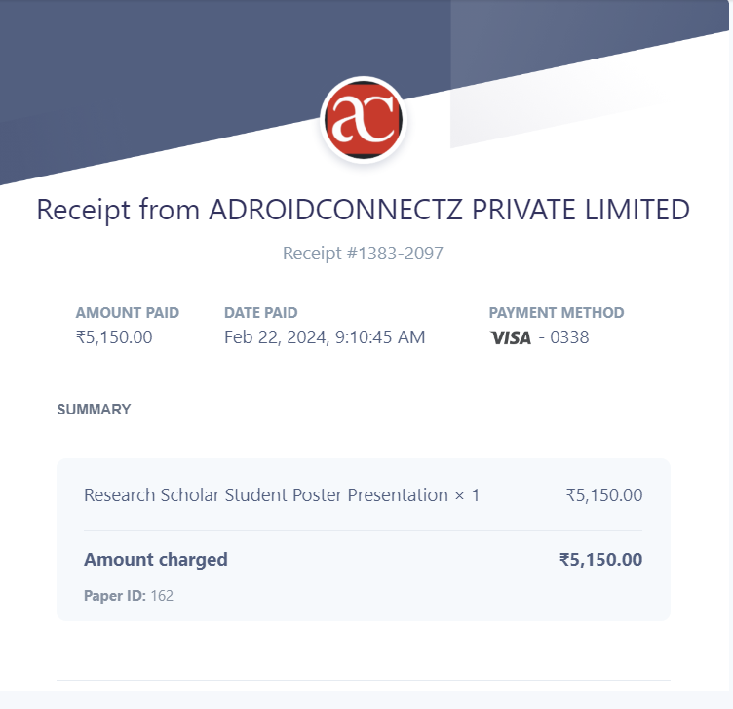

**A Comprehensive Study On Local Retail Through Innovative Strategies**

Shivani

*Department of Computer Science KIET Group of Institutions* Delhi-NCR, Ghaziabad,

Uttar Pradesh, India

[shivani@kiet.edu](mailto:shivani@kiet.edu)

Gaurav Dubey

*Department of Computer Science KIET Group of Institutions* Delhi- NCR, Ghaziabad,

Uttar Pradesh, India

[gaurav.2024cs1001@kiet.edu](mailto:gaurav.2024cs1001@kiet.edu)

Hardik Soni

*Department of Computer Science KIET Group of Institutions* Delhi- NCR, Ghaziabad,

Uttar Pradesh, India

[hardik.2024cs1070@kiet.edu](mailto:hardik.2024cs1070@kiet.edu)

Pushkar Saraswat

*Department of Computer Science KIET Group of Institutions* Delhi- NCR, Ghaziabad,

Uttar Pradesh, India

[pushkar.2024cs@kiet.edu](mailto:pushkar.2024cs@kiet.edu)

***Abstract*:**

An e-commerce website that permits a customer to purchase items and/or services from a store that are not only globally available but also connects the local stores. This website will be a one stop solution for the customers as it will be able to compare the prices of the item searched by the customers in an efficient manner with global as well as local distributors. It also provides a choice to the customer to either search the item through company name, product name. Additionally, helps the retailers and shopkeepers to expand their network by connecting to the local customers with the help of technology. Lastly, will satisfy the customer with the product availability at least price and by conducting successful user review. This project named Naturally Unique treasures & items (NUTI) aims to leverage modern technologies like Django using python to create a comprehensive e-commerce web application.

**1.Introduction**

Businesses around the world are currently faced with a choice: adapt to the ever-changing landscape of technology, or risk becoming obsolete by clinging to traditional brick-and-mortar practices [1]. Enterprises are struggling to stay relevant in the face of fierce competition from online retail giants such as Amazon. We hope to provide a solution to various retailers and shop owners through this project by making it easier for them to attract local customers who want to buy their desired products at the most competitive prices and from nearby locations. When it comes to item selection, our project revolves around catering to customer preferences. The primary goal of our initiative is to develop a website that efficiently meets customer demands while minimizing costs.

**2. Literature Survey**

The purpose of an E-commerce Web Application for Local Stores is to automate existing manual applications using computerized equipment and a full-fledged mobile or web application. Jacob, J. [4] paper’s study helps us to allow the storage of valuable data and information for longer periods, allowing for easy access and manipulation. With the help of the study the Online E-commerce Application is made to be error-free, secure, reliable, and fast management, allowing users to focus on other activities rather than record keeping. It helps stores better utilize resources and maintain computerized records without redundant entries. Another paper by J. Andres [3] explores the impact of "localiation" on the business practices and marketing strategies of small retailers in Ghaziabad, Delhi, etc. The research focuses on three key themes: place, people, and promotion. The findings suggest that place attractiveness, word-of-mouth customer-to-customer marketing, customer service beyond simple product advice, community embeddedness, and informal but meaningful interpersonal relations between shop owners and customers are key pillars of the "localisation" strategic marketing approach pursued by small retailers. Kirby [6] discuss Customers want to purchase local products associated with their own health but don't want to go out of their way to get them. Retailers should emphasize the availability of local items and create perceived consumer effectiveness by making information about the benefits of buying local items available in stores. Proving that products do what they should and promoting their social and environmental benefits can increase intent to purchase and actual purchasing. Marketing is also a dynamic business activity that has evolved due to crises, technological changes, and technological advancements. This has been explained by Shah, Fahid [7]. Marketing executives now need to be market-driven in their strategic decision-making, requiring accurate and timely information about customers, products, and the marketplace. Product research is a crucial process that helps companies understand customer needs and refine new product ideas. It is essential for new product development and helps organizations gain a competitive advantage and leadership position in the market.

**3.METHODOLOGY**

The methodology adopted for the development of NUTI, a comprehensive e-commerce platform, encompassed several key stages tailored to meet the unique requirements and objectives of the project. The methodology was structured to ensure efficiency, collaboration, and innovation throughout the project lifecycle.

1. Research and Requirements Gathering

The project commenced with extensive research and requirements gathering to gain insights into the e-commerce industry, user preferences, and market trends. This phase involved analyzing competitor platforms, conducting user surveys, and engaging with stakeholders to identify key features and functionalities desired for NUTI.

2. Planning and Scope Definition

Based on the research findings, the project scope and objectives were defined, taking into consideration the identified user needs and business goals. A detailed project plan was developed, outlining tasks, timelines, resource allocation, and deliverables. This phase involved prioritizing features, defining milestones, and establishing success criteria to guide project execution.

3. Design and Development

With the project plan in place, the design and development phase commenced. This involved translating requirements into actionable design specifications and technical architecture. Prototyping, wireframing, and iterative development methodologies were employed to ensure alignment with user needs and project goals. Collaboration between designers, developers, and stakeholders facilitated the creation of a visually appealing and user-friendly platform.

4. Testing and Quality Assurance

Quality assurance was a paramount consideration throughout the development process. Rigorous testing methodologies, including functional testing, usability testing, and security testing, were employed to validate functionality, identify defects, and ensure adherence to quality standards. Feedback from testing phases was used to iteratively refine and improve the platform.

5. Integration and Deployment

Upon successful testing and validation, the platform entered the integration and deployment phase. This involved integrating with third-party services such as payment gateways and shipping providers, as well as deploying the platform to production environments. Deployment activities were carefully coordinated to ensure a seamless transition and minimize disruption to users.

6. User Onboarding and Training

Post-deployment, user onboarding and training activities were conducted to familiarize users with the platform's features and functionalities. Training materials, tutorials, and support documentation were provided to empower users to make the most of NUTI's capabilities and maximize their shopping experience.

7. Monitoring and Optimization

The project team implemented monitoring and analytics tools to track user behavior, system performance, and key performance indicators (KPIs). Continuous monitoring enabled proactive identification of issues and optimization opportunities, ensuring a seamless and responsive user experience.

8. Iterative Improvement and Innovation

Throughout the project lifecycle, the team embraced an iterative approach to development, allowing for flexibility and adaptation based on user feedback and evolving market trends. Continuous improvement practices were embedded within the project framework to foster innovation, responsiveness, and ongoing enhancement of the NUTI platform.

By following this methodology, the project team successfully navigated challenges, met stakeholder expectations, and delivered a robust and user-centric e-commerce platform that embodies the essence of Naturally Unique Treasures & Items.

**4.RESULT**

The following are some of the steps that are taken to complete this portal:

4.1 Requirement Analysis:

During this step, the features and requirements were collected, analyzed, refined, and scrutinized. The following three steps were taken during requirement analysis: 6.1.1 0 Level DFD (Zero level Data Flow Diagram): It was constructed. A zero level DFD, also known as a context diagram, is a simple model that aids in the identification and definition of the interfaces and boundaries between the external world and the proposed system[12]. It can be used to identify entities that interact with the proposed system but are not part of it. The figure below depicts the various entities that interact with the portal.

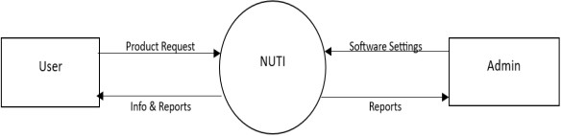

* + 1. ***Modelling the requirements***: Following the structure of zero-level DFD, we created models that included level-1, level-2 DFD, and entity- relationship diagrams to assist in identifying missing, incorrect, superfluous, and inconsistent requirements. Figure 6 depicts the ER Diagram of the same.
    2. ***Finalizing the requirements-***We finalize the requirements once we have a better understanding of the system and its behaviour, as well as any ambiguities or inconsistencies have been resolved.

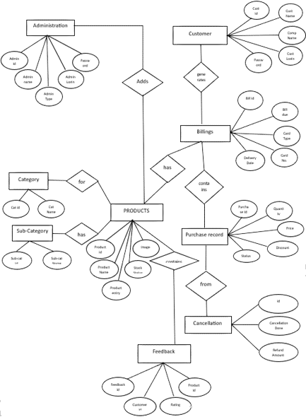

* 1. ***Main Interface***: This is the portal and website's landing page. This will serve as an umbrella through which users can access a variety of resources and utilize the portal's various functionalities. The figure below depicts the main interface and landing page.

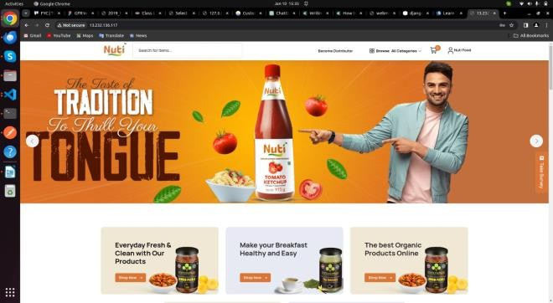

## **Fig. 4.1-Main Interface**

**4.2 *Login/Signup:*** Each user who wants to access the resources and the functionalities provided by NUTI (Naturally unique Treasures and Items) need to create an account with the website, so that personalized reports and product tracking can be enabled for every individual and a dynamic dashboard could be allotted

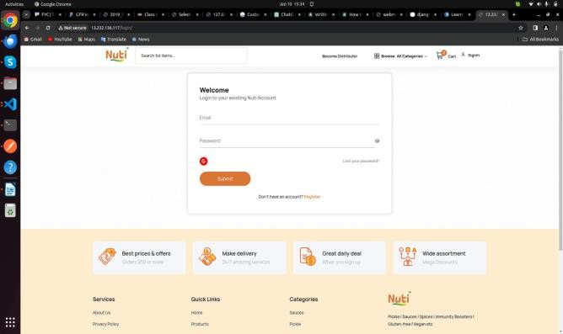

## 

## **Fig. 4.2-Login/Sign up page**

* 1. 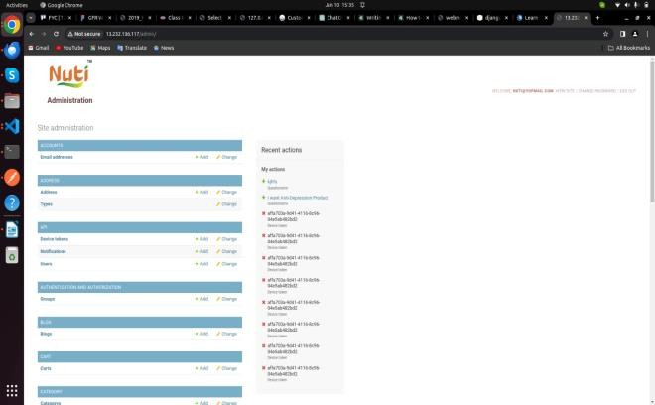***Our Services:*** Our services include satisfying the various demands of the customers as well as the seller by providing them platform for purchasing and selling respectively.

**Fig. 4.3-Admin services**

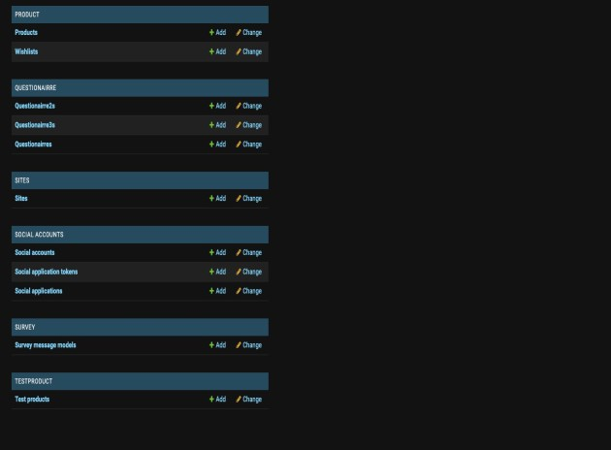

**Fig. 4.4-Product description(Admin) page**

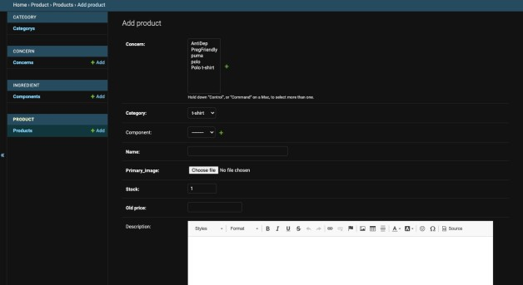

**Fig. 4.5-Add Category (Admin) page**

**5.CONCLUSION**

E-commerce can significantly contribute to a country's progress and development if given the right impetus and a good environmental framework. Through our project, we attempted to assist local shopkeepers in connecting with technology [13] and increasing their income by informing customers about product availability at their shops at reasonable prices.

**6.REFERENCES**

[1] Sapna Juneja, Abhinav Juneja, Gaurav Dhiman, Sanchit Behl, Sandeep Kautish, "An Approach for Thoracic Syndrome Classification with Convolutional Neural Networks", Computational and Mathematical Methods in Medicine, vol. 2021, Article ID 3900254, 10 pages, 2021. <https://doi.org/10.1155/2021/3900254>

[2]Shubham Salunke, Shubham Rajiwade, Deepak Yadav, S.K.Sabnis, "SMART HEALTH PREDICTION SYSTEM USING MACHINE LEARNING", IJRAR - International Journal of Research and Analytical Reviews (IJRAR), E-ISSN 2348-1269, P- ISSN 2349-5138, Volume.7, Issue 1, Page No pp.483-488, March 2020, Available at : http://www.ijrar.org/IJRAR2002068.pdf

[2] Vijayarani, D.S., & Dhayanand, M.S. (2015). Liver Disease Prediction using SVM and Naïve Bayes Algorithms..

[3] Rahman, A. K. M. & Shamrat, F.M. & Tasnim, Zarrin & Roy, Joy & Hossain, Syed. (2019). A Comparative Study On Liver Disease Prediction Using Supervised Machine Learning Algorithms. 8. 419-422.

[4] S. F. Khorshid and A. M. Abdulazeez, “BREAST CANCER DIAGNOSIS BASED ON K-NEAREST NEIGHBORS: A REVIEW,” PalArch’s J. Archaeol. Egypt/Egyptology, vol. 18, no. 4, pp. 1927–1951, 2021.

[5] Kishan Patel, Manu Nair, Subham Phansekar, “Diabetes prediction using Machine Learning”, 2021 IJSER, Volume 12, issue 3, March 2021.

[6] Rani, KM. (2020). Diabetes Prediction Using Machine Learning. International Journal of Scientific Research in Computer Science, Engineering and Information Technology. 294-305. 10.32628/CSEIT206463

[7] Mahboob Alam, Talha & Iqbal, Muahammad & Ali, Yasir & Wahab, Abdul & Ijaz, Safdar & Baig, Talha & Hussain, Ayaz & Malik, Muhammad & Mehdi, Muhammad & Ibrar, Salman & Abbas, Zunish. (2019). A model for early prediction of diabetes. Informatics in Medicine Unlocked. 16. 100204. 10.1016/j.imu.2019.100204.

[8] Alanazi EM, Abdou A, Luo J. Predicting Risk of Stroke From Lab Tests Using Machine Learning Algorithms: Development and Evaluation of Prediction Models. JMIR Form Res. 2021 Dec 2;5(12):e23440. doi: 10.2196/23440. PMID: 34860663; PMCID: PMC8686476.

[9] Gupta, Nisha & Dharmale, Gulbakshee & Parmar, Darshana. (2021). HEART DISEASE PREDICTION USING MACHINE LEARNING. 10.13140/RG.2.2.16604.92800.

[10] Rindhe, Baban & Ahire, Nikita & Patil, Rupali & Gagare, Shweta & Darade, Manisha. (2021). Heart Disease Prediction Using Machine Learning. International Journal of Advanced Research in Science, Communication and Technology. 267-276. 10.48175/IJARSCT-1131.

[11] Rajkumar, Asha & Reena, Mrs. (2009). Diagnosis Of Heart Disease Using Datamining Algorithm. Global J Comput Sci Technol. 10.

[12] Jindal, Harshit & Agrawal, Sarthak & Khera, Rishabh & Jain, Rachna & Nagrath, Preeti. (2021). Heart disease prediction using machine learning algorithms. IOP Conference Series: Materials Science and Engineering. 1022. 012072. 10.1088/1757-899X/1022/1/012072.

[13] Rahman, A. K. M. & Shamrat, F.M. & Tasnim, Zarrin & Roy, Joy & Hossain, Syed. (2019). A Comparative Study On Liver Disease Prediction Using Supervised Machine Learning Algorithms. 8. 419-422.

[14] Gulia, Anju, Rajan Vohra and P. Ithaya Rani. “Liver Patient Classification Using Intelligent Techniques.” (2014).

[15] Sailasya, Gangavarapu & Kumari, Gorli. (2021). Analyzing the Performance of Stroke Prediction using ML Classification Algorithms. International Journal of Advanced Computer Science and Applications. 12. 10.14569/IJACSA.2021.0120662

[16] Parihar, A.S., Chakraborty, S.K. (2021) Token-based approach in distributed mutual exclusion algorithms: a review and direction to future research. The Journal of Supercomputing, Volume 77, pp. 14305–14355. https://doi.org/10.1007/s11227-021-03802-8

[17] Parihar A.S., Chakraborty S.K. (2022) Handling of resource allocation in flying ad hoc network through dynamic graph modeling. Multimedia Tools and Applications. https://doi.org/10.1007/s11042-022-11950-z

[18] Parihar, A.S., Chakraborty, S.K. (2022) Token Based k-Mutual Exclusion for Multi-UAV FANET. Wireless Personal Communications. https://doi.org/10.1007/s11277-022-09886-6

[19] Parihar A.S., Chakraborty S.K. (2022) A simple R-UAV permission-based distributed mutual exclusion in FANET. Wireless Networks. https://doi.org/10.1007/s11276-022-02889-y

[20] Parihar, A.S., Chakraborty, S.K. (2022). A Cross-Sectional Study on Distributed Mutual Exclusion Algorithms for Ad Hoc Networks. In: Gupta, D., Goswami, R.S., Banerjee, S., Tanveer, M., Pachori, R.B. (eds) Pattern Recognition and Data Analysis with Applications. Lecture Notes in Electrical Engineering, vol 888. Springer, Singapore. https://doi.org/10.1007/978-981-19-1520-8_3

[21] Parihar, A.S., Prasad, D., Gautam, A.S., Chakraborty, S.K. (2021). Proposed End-to-End to Increase Voter’s Turnout. In: Prateek, M., Singh, T.P., Choudhury, T., Pandey, H.M., Gia Nhu, N. (eds) Proceedings of International Conference on Machine Intelligence and Data Science Applications. Algorithms for Intelligent Systems. Springer, Singapore. https://doi.org/10.1007/978-981-33-4087-9_5

[23] Harsh Khatter, Anil K Ahlawat, “Content curation algorithm on blog posts using hybrid computing”.Multimedia Tools and Applications, Vol. 81, pp. 7589–7609 (2022) https://doi.org/10.1007/s11042-022-12105-w

[24] Harsh Khatter, Anil K Ahlawat, “Web Blog Content Curation Using Fuzzy-Related Capsule Network-Based Auto Encoder”, International Journal of Pattern Recognition and Artificial Intelligence, Vol 36 (2), pp.1-30 [2022).https://doi.org/10.1142/S021800142250001X

[25] Harsh Khatter, Amit Kumar Gupta, Ruchi Rani Garg, and Mangal Sain. 2022. "Analysis of the S-ANFIS Algorithm for the Detection of Blood Infections Using Hybrid Computing" Electronics 11, no. 22: 3733.

https://doi.org/10.3390/electronics11223733

**Patent Details:**

**Proposed Title:**

A Comprehensive Study On Local Retail Through Innovative Strategies.

**MENTOR**:

Prof. Shivani

**MEMBERS:dz**

Gaurav Dubey CS-A(2000290120065)

E-mail: [gaurav.2024cs1101@kiet.edu](mailto:gaurav.2024cs1101@kiet.edu)

Contact no:- 7985433546

Hardik Soni CS-A(2000290120068)

E-mail: [hardik.2024cs1070@kiet.edu](mailto:hardik.2024cs1070@kiet.edu)

Contact no:- 9555669219

Pushkar Saraswat CS-A()

E-mail:-[kiet.edu](mailto:deepak.1923co1010@kiet.edu)

Contact no:- 7078732388

**Field of Invention**

A Comprehensive Study On Local Retail Through Innovative Strategies

**Background**

The primary goal of the project is to provide retailers and shopkeepers with a means of effectively competing against online shopping behemoths like Amazon. The project aims to meet customer demands at the most affordable prices while also obtaining positive feedback by providing services tailored to their preferences. This ensures that businesses remain relevant and competitive in an ever-changing marketplace [10].

**Objective:-**

This website will be one stop solution for the customers as it will :

* Compare the prices of the item searched by the customers in an efficient manner
* Provide a choice to the customer to either search the item through company name, product name.
* Help the retailers and shopkeepers to expand their network by connecting to the local customers with the help of technology
* Satisfy the customer with the product availability in least price and by conducting successful user review.

**Model/Diagram**

**E-R Diagram:-**

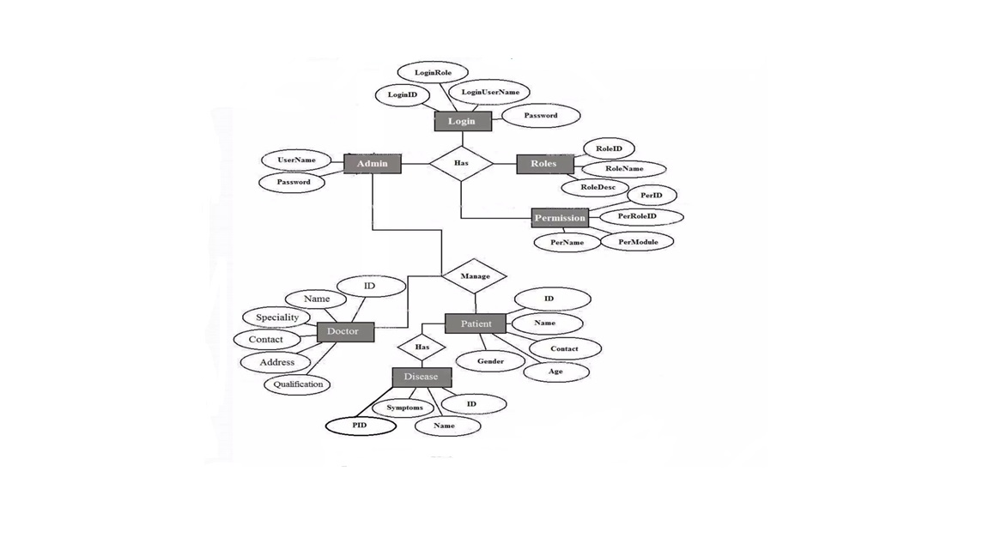

**Data flow diagram:**

**DFD 0:**



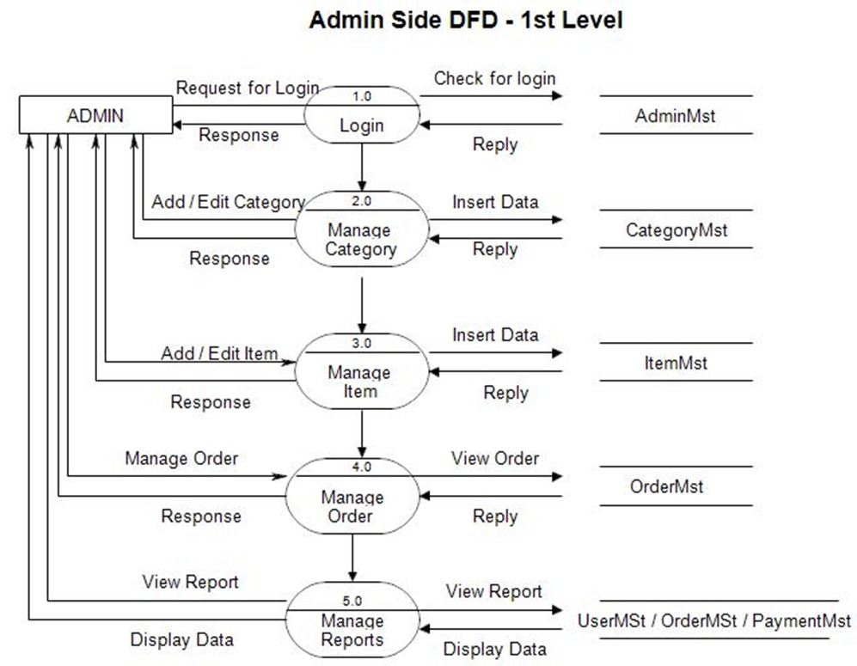

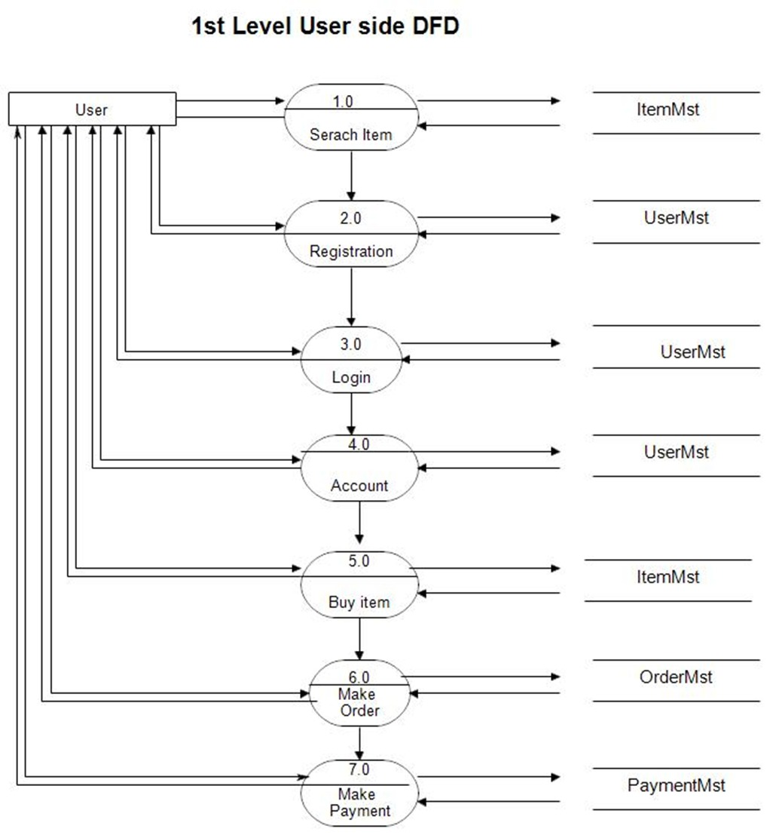

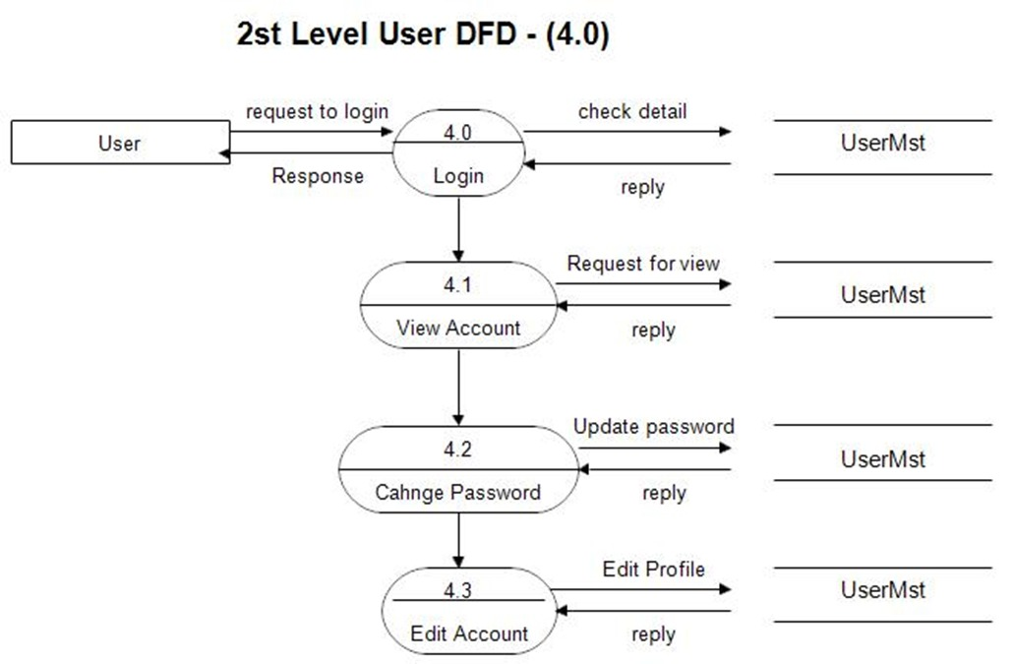

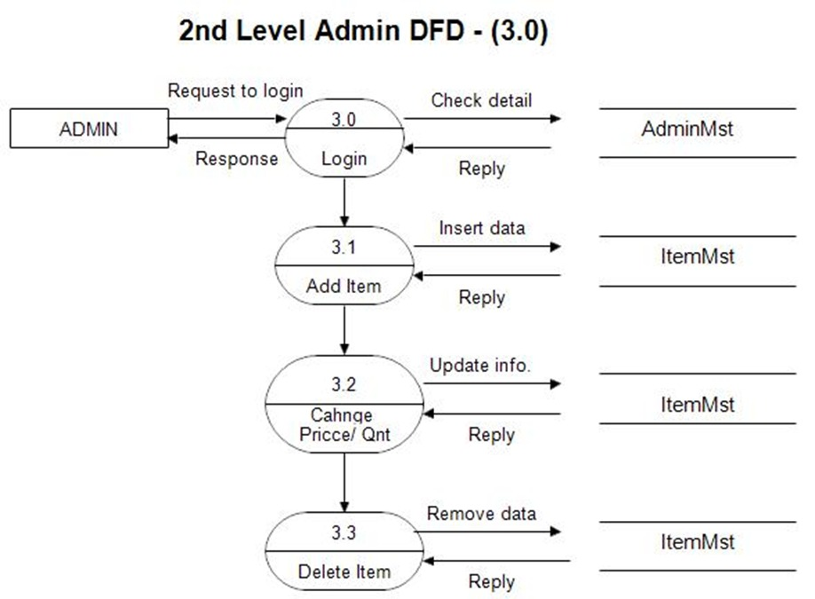

**Innovative Ideas:-**

* "Revolutionizing E-Commerce: Introducing NUTI - Naturally Unique Treasures & Items"
* "Bridging Global Markets with Local Businesses: The NUTI Approach"
* "Empowering Consumers and Local Retailers: The Next Generation E-Commerce Platform - NUTI"
* "Redefining Shopping Convenience: NUTI's Comprehensive E-Commerce Solution"
* "From Local to Global: NUTI's Vision for Seamless Shopping Experience"
* "Innovative Integration: NUTI's Fusion of Global Availability and Local Connections"
* "Navigating the World of Shopping: NUTI's Cutting-Edge Approach to E-Commerce"
* "The Future of Online Shopping: NUTI's Unique Blend of Technology and Community Engagement"
* "Unlocking Opportunities: How NUTI is Transforming Retail Landscape with Technology"

**Technology used:**

**Software :**

* Python
* Django
* Html
* Css
* Windows 7 and above

**Hardware :**

* Processor: intel i3/i5/i7
* RAM : 4/8 GB

**Abstract:-**

An e-commerce website that permits a customer to purchase items and/or services from a store that are not only globally available but also connects the local stores. This website will be a one stop solution for the customers as it will be able to compare the prices of the item searched by the customers in an efficient manner with global as well as local distributors. It also provides a choice to the customer to either search the item through company name, product name. Additionally, helps the retailers and shopkeepers to expand their network by connecting to the local customers with the help of technology. Lastly, will satisfy the customer with the product availability at least price and by conducting successful user review. This project named Naturally Unique treasures & items (NUTI) aims to leverage modern technologies like Django using python to create a comprehensive e-commerce web application.

**End users:-**

Our website stands out as a beacon of reliability and trustworthiness in the online marketplace. With a commitment to excellence, we've implemented state-of-the-art security measures to protect both user and retailer data from any potential threats or breaches. Additionally, our platform boasts a user-friendly interface, allowing for effortless navigation and seamless browsing of our extensive product catalog. We prioritize transparency and integrity in all our dealings, fostering strong relationships built on mutual trust and respect. Furthermore, our robust payment gateway ensures swift and secure transactions, providing peace of mind to both customers and retailers alike. With a dedicated focus on customer satisfaction, we continually strive to exceed expectations and deliver an unparalleled online shopping experience for all our users.

Moreover, our website's account management system empowers users to personalize their profiles, manage their preferences, and track their orders with ease. Through advanced security protocols, including multi-factor authentication and data encryption, we ensure that user accounts remain protected against unauthorized access. Additionally, our platform offers a range of customization options, allowing users to tailor their browsing experience to their unique preferences. Whether it's setting up notifications for favorite products or saving payment information for quick checkout, our website provides a personalized and secure environment for every user.

**Advantages:**

* Save Money: The most significant advantage for customers is the ability to find the best deals and lowest prices on the products they need. By comparing prices across various retailers in one place, customers can avoid wasting time and money visiting multiple websites or stores.
* Convenience and Time-Saving: The website streamlines the shopping experience by eliminating the need to visit multiple websites or stores for price comparisons. This saves customers valuable time and effort, allowing them to find the best deal quickly and easily.
* Informed Decisions: The user review system empowers customers to make informed decisions by providing valuable insights and real-world experiences from other users. This allows them to understand product quality, customer service experiences with different retailers, and overall satisfaction levels before making a purchase.
* Focus on Local Businesses: The website can help customers support local businesses by highlighting products and retailers within their community. This can be particularly appealing to customers who prioritize supporting local vendors and contributing to the local economy.
* Wider Product Selection: By showcasing products from various local retailers, the website provides customers with a broader selection of products to choose from compared to a single store's offerings.
* Advantages for Retailers:
* Increased Reach and Visibility: The website offers local retailers the opportunity to expand their online presence and reach a wider customer base. By registering with the platform, their products and services become visible to a larger audience who might not have discovered them otherwise.
* Targeted Marketing: The platform can potentially offer retailers targeted marketing opportunities. Depending on the website's functionalities, they might be able to showcase special promotions or highlight specific product categories to a relevant customer base within their local area.
* Improved Customer Insights: Retailers can gain valuable customer insights through user reviews. This feedback can help them understand customer preferences, identify areas for improvement, and potentially adjust their product offerings or marketing strategies to better meet customer needs.
* Level Playing Field: The website can create a more level playing field for smaller local retailers by allowing them to compete with larger online stores on price and product visibility. This can be particularly beneficial for retailers who might not have the resources for extensive online marketing campaigns.
* Increased Sales Potential: By attracting new customers and showcasing their products to a wider audience, retailers have the potential to increase sales and grow their business.

**Summary Conclusion:-**

E-commerce can significantly contribute to a country's progress and development if given the right impetus and a good environmental framework. Through our project, we attempted to assist local shopkeepers in connecting with technology [13] and increasing their income by informing customers about product availability at their shops at reasonable prices.

**REFERENCE:-**

Logistics Performance, Ratings, and Its Impact on Customer Purchasing Behavior and Sales in E-Commerce Platforms.

Behavior and Sales in E-Commerce Platforms. M&som-manufacturing & Service Operations Management, (2023).;25(3):827-845. doi: 10.1287/msom.2021.1045 Saqib, Saeed. A Customer-Centric View of E-Commerce Security and Privacy. Applied Sciences, (2023).;13(2):1020-1020. doi: 10.3390/app13021020 Elena, Higueras-Castillo., Francisco, Liébana-Cabanillas., Ángel, F., Villarejo-Ramos. Intention to use e-commerce vs physical shopping. Difference between consumers in the post-COVID era. Journal of business research, (2023).;157:113622-113622. doi: 10.1016/j.jbusres.2022.113622 Gabriel, Lucas., Guilherme, Lerch, Lunardi., Décio, Bittencourt, Dolci. From e-commerce to m-commerce: An analysis of the user's experience with different access platforms. Electronic Commerce Research and Applications, (2023).;58:101240-101240. doi: 10.1016/j.elerap.2023.101240 Awais Muhammad and Samin Tanzila (2012), “Advanced SWOT Analysis of ECommerce”, IJCSI International Journal of Computer science Issues, Vol 9,Issue 2,No 2,pp. 569-574 Blasio,G.,D. (2008), “Urban–Rural Differences in Internet Usage, eCommerce, and eBanking: Evidence from Italy”, Growth and Change, 39.2 , pp. 341–367 Chanana Nisha and Goele Sangeeta, “Future of e-commerce in India”, International Journal of Computing & Business Research, ISSN (Online): 2229-6166 Chou,D.,C. and Chou,A.,Y. (2000), “The E-Commerce Revolution, A Guide to the Internet Revolution in Banking” information systems management,pp.51-57 D’silva, B., D’Silva, S., and Bhuptani, R.,S.,K.(2010), “Behavioral Aspect of Teenagers Towards Internet Banking: An empirical study”, Indian journal of marketing, 40.10, pp.44-53 Mark, S., Ackerman., Lorrie, Faith, Cranor., Joseph, Reagle. Privacy in ecommerce: examining user scenarios and privacy preferences. (1999).1-8. doi: 10.1145/336992.336995 Kenneth, C., Laudon., Carol, Guercio, Traver. (2002). E-commerce: Business, Technology, Society. H. Khatter, S. Arif, U. Singh, S. Mathur and S. Jain, "Product Recommendation System for E-Commerce using Collaborative Filtering and Textual Clustering," 2021 Third International Conference on Inventive Research in Computing Applications (ICIRCA), Coimbatore, India, 2021, pp. 612-618, doi: 10.1109/ICIRCA51532.2021.9544753. A. Sharma, N. Aggarwal, H. Khatter, Saurabh, A. Tripathi and S. Awasthi, "Comparative Analysis of Different Algorithms in Link Prediction on Social Networks," 2023 International Conference on Artificial Intelligence and Smart Communication (AISC), Greater Noida, India, 2023, pp. 1-5, doi: 10.1109/AISC56616.2023.10085359. Khatter, H., & Ahlawat, A. K. (2020). An Algorithmic approach for recommendation systems for web blogs and microblogs. Journal of Xi’an Shiyou University, Natural Science Edition, 16(9), 347-350.